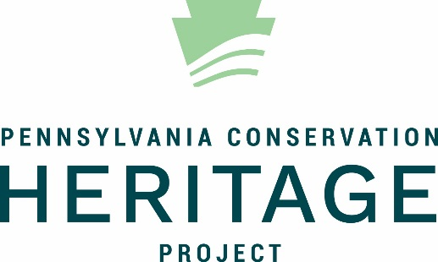

Fact Sheet to accompany “Rachel Carson: Voice of Nature”
“I have always wanted to write, but I don’t have much imagination. Biology has given me something to write about.”
Rachel Carson, 1928
Growing Up Rachel
Born May 27, 1907, Rachel was the third and last child of Maria and Robert Carson, eight years younger than her brother and 10 years behind her sister. Her family lived on a 65-acre property bordering the Allegheny River just northeast of Pittsburgh, in Springdale, PA.
Rachel’s mother followed the 19th century nature study movement where nature was considered the best teacher. She herself was an exceptional naturalist. Rachel had the run of their land and spent hours exploring it.
At a young age, Rachel decided she would become a writer. Her family and teachers saw her talent and encouraged her. She submitted her first piece to the national magazine St. Nicholas at age 10 and earned a ‘Silver Badge’ and $10 (equivalent to nearly $200 in 2018). The following year, another story won the magazine’s ‘Gold Badge,’ and she went on to publish several more stories.
Rachel graduated at the top of her high school class. With a combination of scholarships and significant financial sacrifice by her family (her mother sold many of their good belongings), she attended the Pennsylvania College for Women in Pittsburgh, now Chatham University. She started as an English major, but a biology class her sophomore year, with a professor who believed women could learn science just as well as men, led her to change her major – and the course of her life.
Rachel graduated with honors in 1929. She then earned a Master of Science in zoology and genetics from Johns Hopkins University.
Becoming a Scientist and Writer
Rachel taught part time at Johns Hopkins and the University of Maryland and began writing for the Baltimore Sun. In 1936, she got a job with the Bureau of Fisheries (now the Fish and Wildlife Service). She wrote scientific pamphlets for the general public – a job that combined her talents of writing and biology and showed her to be a skillful writer as well as a top-notch scientist. During this time, she wrote her first book, Under the Sea-Wind, in 1941, about life in the ocean. The book sold poorly; as Rachel said, “the rush to the book store that is the author’s dream never materialized.”
By 1949, Rachel was editor-in-chief of all Fish and Wildlife Service publications – rare for a female scientist at the time. Her second book, The Sea Around Us, came out in 1951 to much greater success – it stayed on The New York Times bestseller list for months. In 1952, she resigned from her government job to research and write full time, publishing her third book, The Edge of the Sea, in 1955.
Silent Spring
In 1958, Rachel began writing Silent Spring, published in 1962. She focused her new book on the interconnectedness of all living things and how human actions, particularly pesticides, were causing great harm. She described how pesticides applied to trees ran off into cow pastures, eventually making their way into human milk supply. Rachel showed that once pesticides entered the food chain, they worked their way up to threaten bird and fish populations and eventually people, especially children. Much of the research Rachel cited wasn’t new, but she was the first to put it all together for a general audience. She criticized scientists for saying it was safe to widely use pesticides, including DDT, despite poor results and harmful side effects to the environment. She didn’t believe we should completely abandon pesticides but called for a more moderate and conscientious approach.
It was the first time a popular author made such a compelling case that synthetic pesticides, particularly DDT, were causing such serious harm to the natural world. The chemical industry immediately launched a well-funded counterattack. They argued that without pesticides, we would be overrun by insects and not able to grow enough food to survive. The uproar lead President Kennedy to create the Presidential Science Advisory Committee to investigate; the committee validated Rachel’s arguments and recognized her for bringing pesticide abuse to light.
Silent Spring sold over 600,000 copies in 1962, and many credit the book with launching the modern environmental movement. A host of legislation followed: the Clean Air Act (1963), the creation of the Environmental Protection Agency (1970), the Clean Water Act (1972), and the Endangered Species Act (1973).
Rachel Carson’s Legacy
Rachel died of cancer on April 14, 1964. Through her thoroughly-researched and easily-understood story in Silent Spring, she sounded an alarm that got everyone’s attention. Ten years and two presidents later, the production of DDT and its use in agriculture was banned in the US. Her warnings about pesticide persistence and how little we knew about the interactions with the natural world laid the groundwork for significant environmental legislation, as well as pesticide safety warnings. She made a compelling case that we couldn’t poison nature without poisoning ourselves. She sparked a grassroots environmental movement where people demanded a say in what was happening in their environment.

